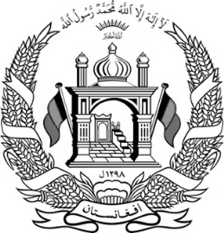
Islamic Republic of Afghanistan
Ministry of Interior Affairs
Department of Population Statistics
Population Statistics Office
Province: XXXXXX
District: XXXXXX
No: XXXXXX Village: XXXXXX
Price: 10 AFN Home No:
Identification |  |  |  | Physical Characteristics
Name |  | XXXXXX |  | Height |  |  | Medium
 |  |  |  | Color of eye |  |  | Hazel
Father’s Name |  | XXXXXX |  | Eyebrow |  |  | Separated
 |  |  |  | Color of skin |  |  | Wheaten
Grand Father’s Name |  | XXXXXX |  | Color of hair |  |  | Black
 |  |  |  | Other sings
Place of Birth |  | Mentioned Village |  | Disability
Date of Birth
Religion |  | Islam |  | Military Service |  |  |  |  | Nomad/ Seasonal Residence
Ethnicity |  | Afghan |  | Entry date |  |  |  |  | Summer
Occupation |  | XXXXXX |  | Releasing Date |  |  |  |  | Winter
Gender |  | XXXXXX |  | Division |  |  |  |  | Tribe
Marital Status |  | Single |  | Other |  |  |  |  | Head of Tribe
Family No. |  |  |  |  |  | Volume No.XX, Page No. XX, Registry No. XX
Languages |  | Mother Tongue |  | XXXXXX
Sukok No. , Date: (XXXXXX)
(XXXXXX)
 |  | Foreign
Signature of Authorized Officer |  |  |  | Signature of Chief Officer |  |  |  |  | Signature of ID Holder
Name | Grade |  |  | Name | Grade |  |  |  | Father’s ID: Volume No. XX, Page No. XX, Registry No. XX

Certified true translation.

